**1**

**.**

**Introduction**

Nowadays, many enterprises use the structural design and solutions of J2EE

technology. The classic structure of J2EE, Model - View - Control (MVC), is the

most commonly seen structure which the J2EE application is based on. MVC is

mainly suitable for interactive web applications, especially when there are large

numbers of pages, many visitors and displayed data.

The SmartADF development framework is a framework based on the classic J2EE

framework to develop enterprise application software. The framework has several

new concepts:

**Using Models to Meet the Needs of Changing Enterprise Applications**

This framework views enterprise application software from four dimensions:

interface, data model, workflows and data flow.

These four dimensions constitute

more than 80% contents of the enterprise application software. It can be said that

enterprise applications are created, changed and evolved according to these four

aspects. This method is a model-driven enterprise application strategy, which also

provides the whole SmartADF theoretical basis and the central concept. SmartADF

also provides an excellent solution techniques and methods by the four dimensions.

**SmartADF Adopts Model Driven Technology (MDA)**

It performs business analysis, modeling, development and testing based on the

design platform of fully modeled by using model-driven technology (MDA).

Eventually, it provides a business system with strong reusability, high stability,

While there are a majority of enterprises using the J2EE technological structure design

and solutions, it is difficult to fulfill the requirements in the complex and various, multi-

point and wide-spread business implementation level by relying solely on object and

interface oriented technology. SmartADF (Smart Application Develop Framework-Java)

is a rapid application development framework. It is a framework suitable for developing

the enterprise applications software based on J2EE framework. It adopts a strict

hierarchical design. Hence, different levels of developers can find the right level to work.

The use of interface coupling between the layers could be realized. It has been proved by

the practice result that SmartADF provides a more abundant set of components and

technical specifications to develop fast, stable and efficient enterprise applications

compared with the traditional J2EE development framework, which improves the efficiency of

unified

style

and

quality

assurance

for

customers.

SmartADF

development

framework can be implemented to realize the development process control of the

speedy SMART project. It directly achieves from project analysis to system

deliverance

**A New Way to Write Service Code**

In JAVA, the service may be category or interface, which is not suitable for

writing business service code. While functions orientation, object orientation and

interface orientation are supports from the linguistic perspective, the service

orientation and the service restructure are supports from the structural perspective.

In this framework, the business service is called BSO, namely business service

objects. This object is very simple to write. The framework uses the annotation

mode, making the writers can provide the BSO prototypes without inheriting a

parent class or implementing the interface. Each BSO can have multiple service

methods and each of them can specify the input message as well as output message

in advance.

**The Functions are Extended by Using Plug-ins**

There is an extendpoints.xml extension file in a jar package which can be used to

define extension points. Thus, when this jar package is placed, the function is

automatically perceived. When removed, its extended function disappears.

**SmartADF Offers Integrated Features at Multiple Levels**

For example, it provides an integrated way for the applications with the same

framework in the core technology layer. Besides, among the application systems

developed by the SmartADF, the call is seamless. Moreover, in the core layer, it

also provides a pass mode to achieve previous user identifications authorization

among different systems. However, in the upper level business process, it can also

integrate. At this time, the integration turns into a foreign call within a process so as

to achieve business synergistic effect. The upper integration layers, BIS and DIS,

provide heavy weight integration. They not only belong to the functional level but

also the developmental level. BIS and DIS are developed based on the FFK layer of

SmartADF. They have the natural integration ability with the business applications

at the upper level.

**The Development Framework of SmartADF is Achieved by Model-driven**

**Technology (MDA)**

It conducts business analysis, modeling with high stability, uniform style and

guaranteed quality based on the design platform of fully modeled. It provides an

abundant set of components and technical specifications for the development of

rapid, stable and efficient enterprise applications.

This paper will briefly introduce SmartADF, the design and the achievement of

BizVoucher which is widely used (a processing model of business evidence) by

examples of business proof.

**. The Development Framework of SmartADF Enterprise Applications**

SmartADF development framework is established to developenterprise

applications software on the foundation of the classic J2EE framework. It provides a

wide set of components and technical specifications for the development of fast,

stable and efficient enterprise applications. The functional hierarchy of Smart ADF

is illustrated by Figure 1 below:

**Figure 1. SmartADF Development Framework** **Infrastructure Layer**

A wide range of services and products provided by IT vendors, including

infrastructures such as database, middleware, MQ, ESB, distributed storage, cloud

computing and so on. SmartADF framework has extensive experience to integrate and

interoperate with the infrastructure.

**2.2 Core Technology Layer**

This layer is located in the M layer of MVC model, which is in charge of the

management of basic service objects and the database connection pool. Besides, it

encapsulates the MQ, caching and distributed storage interface. In addition, this layer also

provides a monitor for the frame services running.

**2.3 Business Services Layer**

This layer is located in the M layer of MVC, which is responsible for the encapsulation

of enterprise business functions. This layer provides metadata, master data, transaction

data and other models. It also provides business services, business services restructuring,

business documents, workflow platform and authority management components. It also

offers customized visualization tool so that users can easily configure all documents,

workflows and data models.

**2.4 Integration Layer**

With business integration platform (BIS), it exchanges business data with all kinds of

external business systems. It can also achieve the data exchange at the database level and

the mutual integration with the deployed core ESB platform

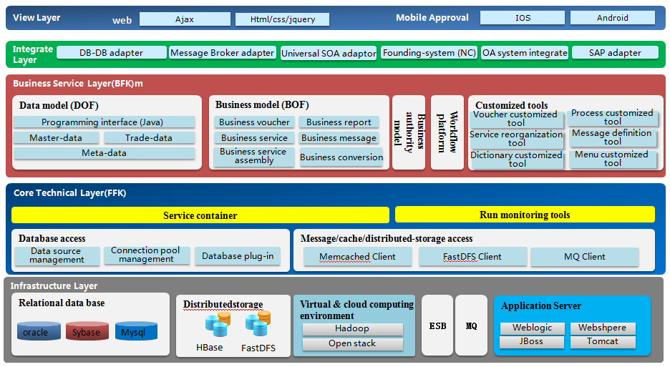

**Figure 1. SmartADF Development Framework** **Infrastructure Layer**

View Layer

This is located in the V layer of MVC and is based on the ajax technology. Pure web

service components are developed based on jquery core. The web demonstration of

mobile operations system is achieved through interface exploration.

SmartADF integrates a lot of basic functions which contribute to the enterprise

applications such as workflow tools, data flow tools, data model, business model etc. To

realize the enterprise-level data processing, SmartADF foreground mode applies Ajax

pure-web technology as the foundation and takes use of Jquery as the core base. From the

technical aspect, the prominent characteristics of SmartADF are listed as follow:

1. SmartADF is extended based on the J2EE standard framework. It makes full use of

J2EE core function, allows full play to the advantages of J2EE such as portability, inter-

platform ability, high scalability etc.

1. Hierarchical design concept, plug-in extensibility. The purpose of hierarchical

design is to achieve logical decoupling . Hierarchical design is able to improve the

complexity of system integration significantly. In SmartADF, separating the technology

layer and business layer is the first thing in the whole layering process. Then, separate the

implementation layer and the framework layer. As the result, different developers can use

different framework layers to work.

1. Model driven. SmartADF is model driven. This feature is mainly embodied in the

abstract and realization of the business model. It is model-based that is the obvious

characteristic of SmartADF, which is more advantaged than general technical framework.

Business is more flexible with model. In addition, changing customer requirements into

software products becomes more convenient. Thus customers can acquire the better

service.

1. Interface-service-component-process. In Smart ADF, the programmers in

technology layer can conduct Interface-Oriented programming, the programmers in

business layer can conduct Service-Oriented programming and the programmers in real-

customization layer can conduct Component-Oriented programming. Finally, what is

presented to the users is a highly flexible, customizable and scalable business application

system.

1. Swing supported. Swing in the J2SE is a powerful set of components. Swing is very

suitable for intensive operation software applications, such as accounting system,

settlement system and reporting system. These systems have many operating points and

high requirements, meanwhile they require the agile reaction. Swing precisely realizes

these features. As a part of J2SE, Swing is continually reinforced. It also supports inter-

platform, that is to say Swing Can simultaneously run on Windows, Linux and Mac OS

operation systems.

(6) WEB supported. Although Swing in J2SE is powerful, there are many occasions,

integrated and required to unified log in, the application of Swing is difficult to merge.

What`s more, in conditions of poor network environment, the utilization of a Swing

application is also very inconvenient. Meanwhile, Swing must run in the JRE running

environment with client and needs to download JAR package when applying an upgrade.

(7) Customization development. Since SmartADF has adopted abundant technologies

and components, the core is very flexible. The finally produced software platform

provides high customizability. It is mainly represented in the flowing aspects: service-

customized, interface-customized and processes-customized.